1.Write an assembly language program for adding two 8-bit data A7 A6 A5 A4 A3 A2 A1 A0 and B7 B6 B5 B4 B3 B2 B1 B0 using 8085 processor

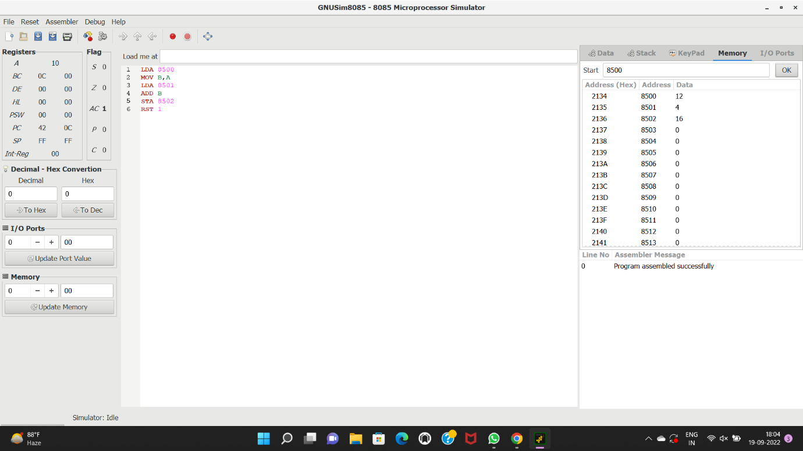

2.Write an assembly language program for subtraction of two 8-bit data A7 A6 A5 A4 A3 A2 A1 A0 and B7 B6 B5 B4 B3 B2 B1 B0 using 8085 processor. 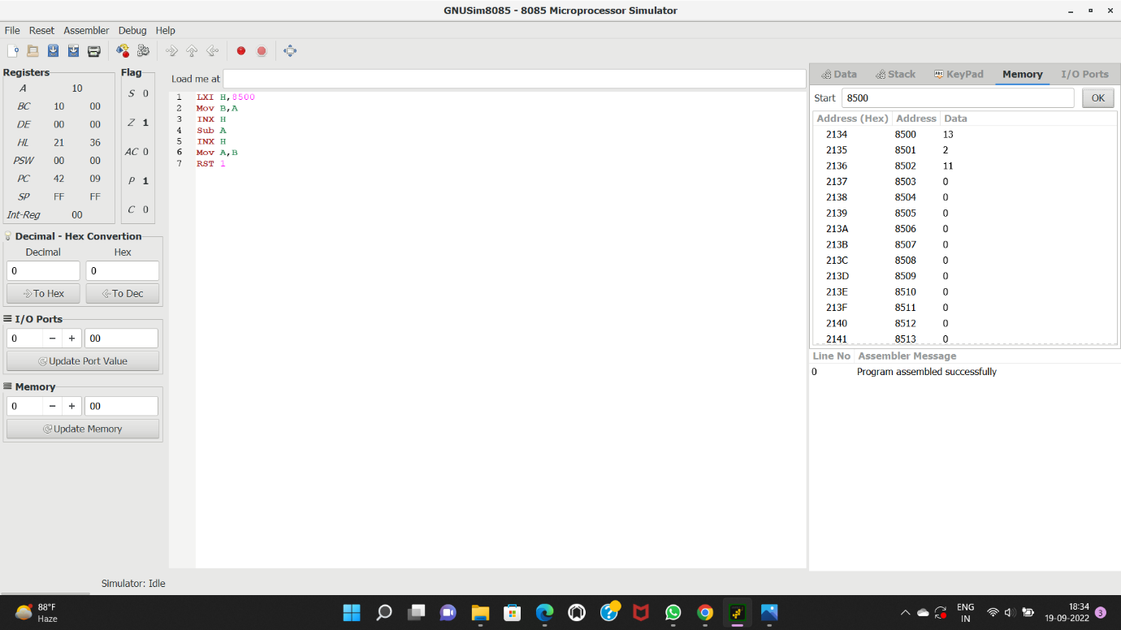

5.Write an assembly language program for multiplication of two 8-bit data A7 A6 A5 A4 A3 A2 A1 A0 and B7 B6 B5 B4 B3 B2 B1 B0 using 8085 processor.

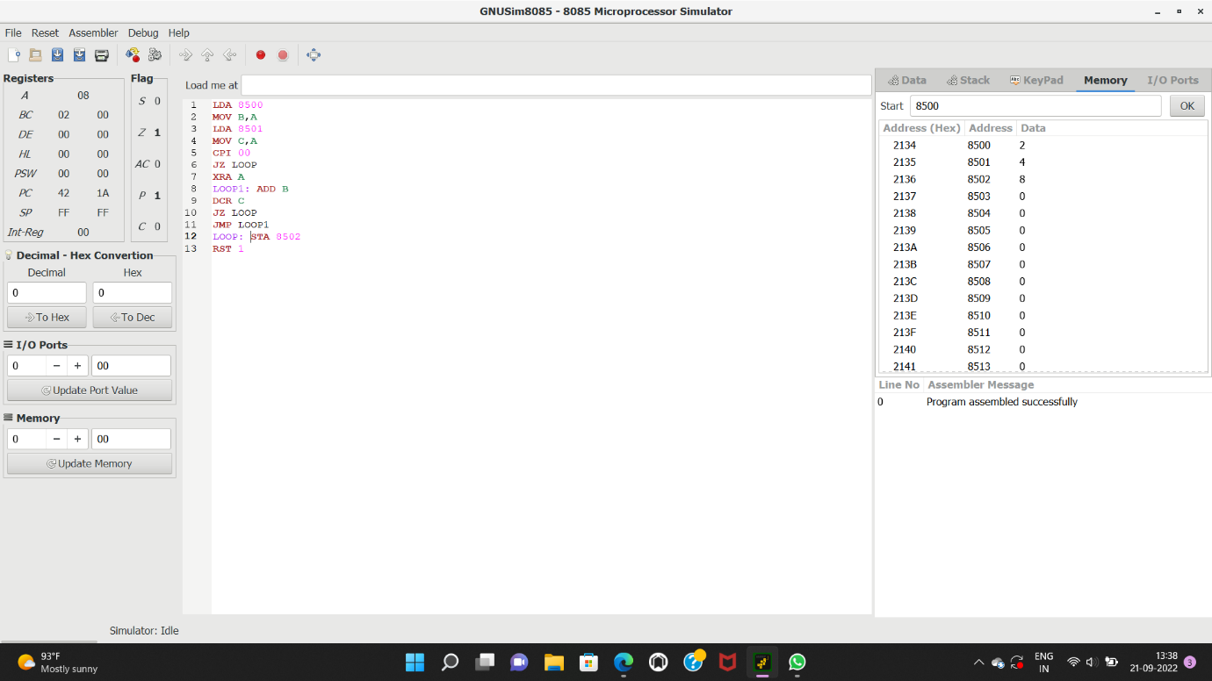

6.Write an assembly language program for division of two 8-bit data A7 A6 A5 A4 A3 A2 A1 A0 and B7 B6 B5 B4 B3 B2 B1 B0 using 8085 processor.

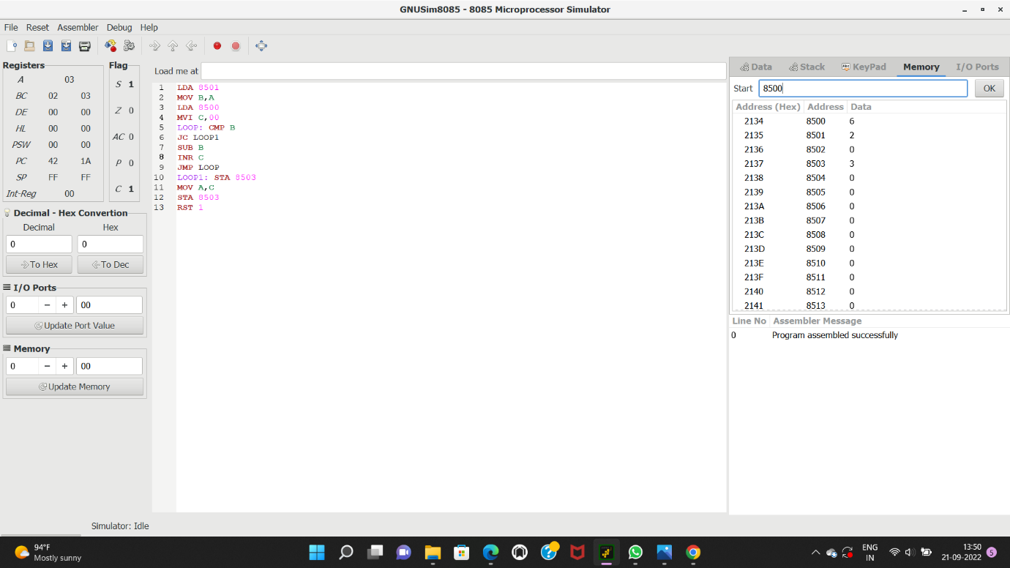

7.Write an assembly language program for multiplying two 16-bit datausing 8086 processor.

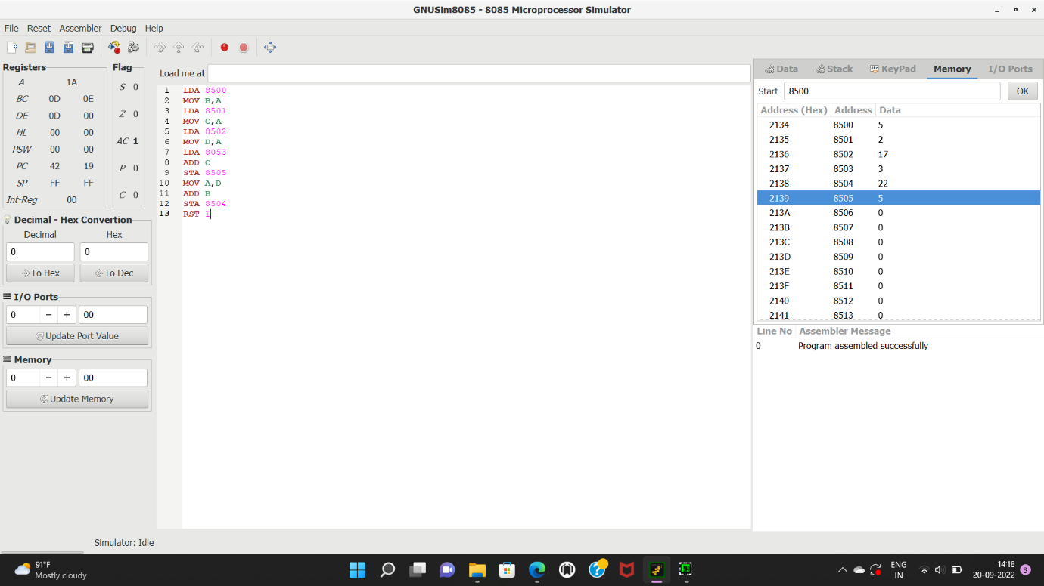

8. Write an assembly language program for dividing two 16-bit datausing 8086 processor.

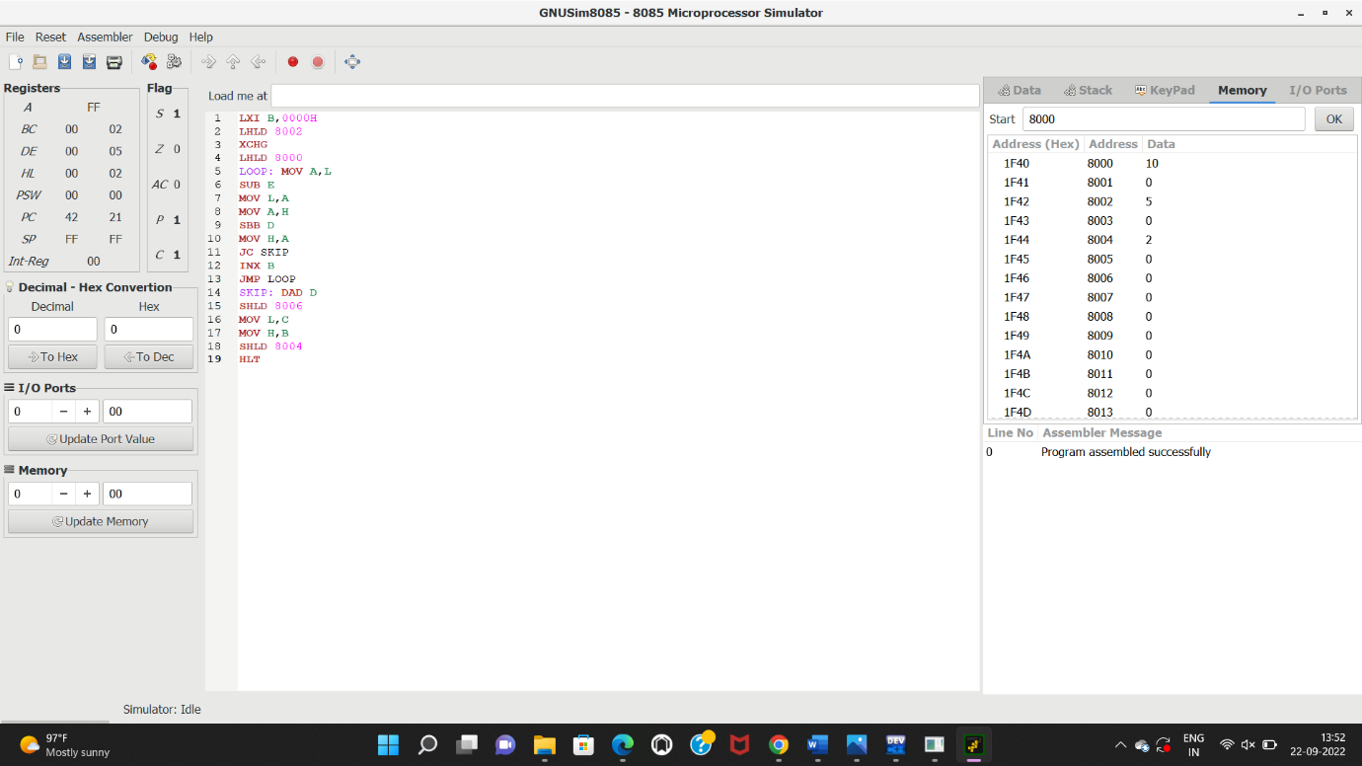

9.Design and implement 2-bit half adder using logisim simulator

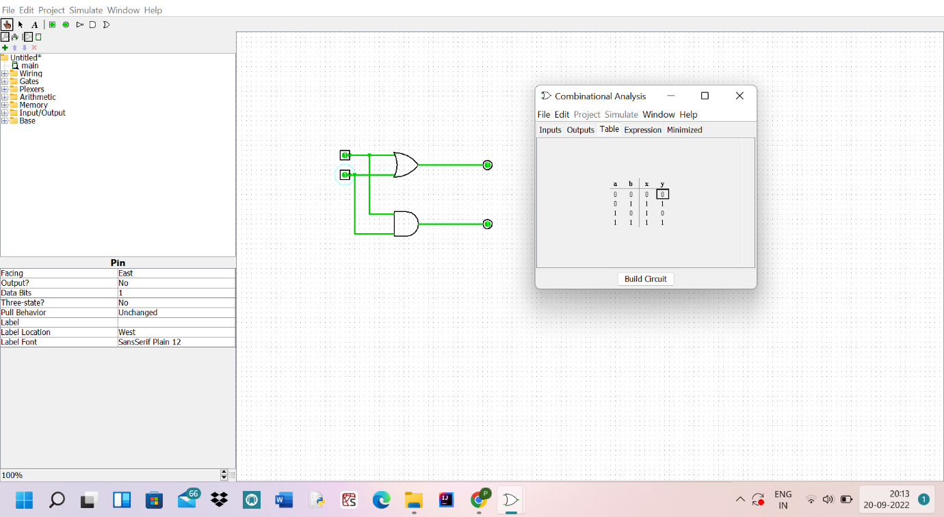

10.Design and implement 3-bit full adder using logisim simulator.

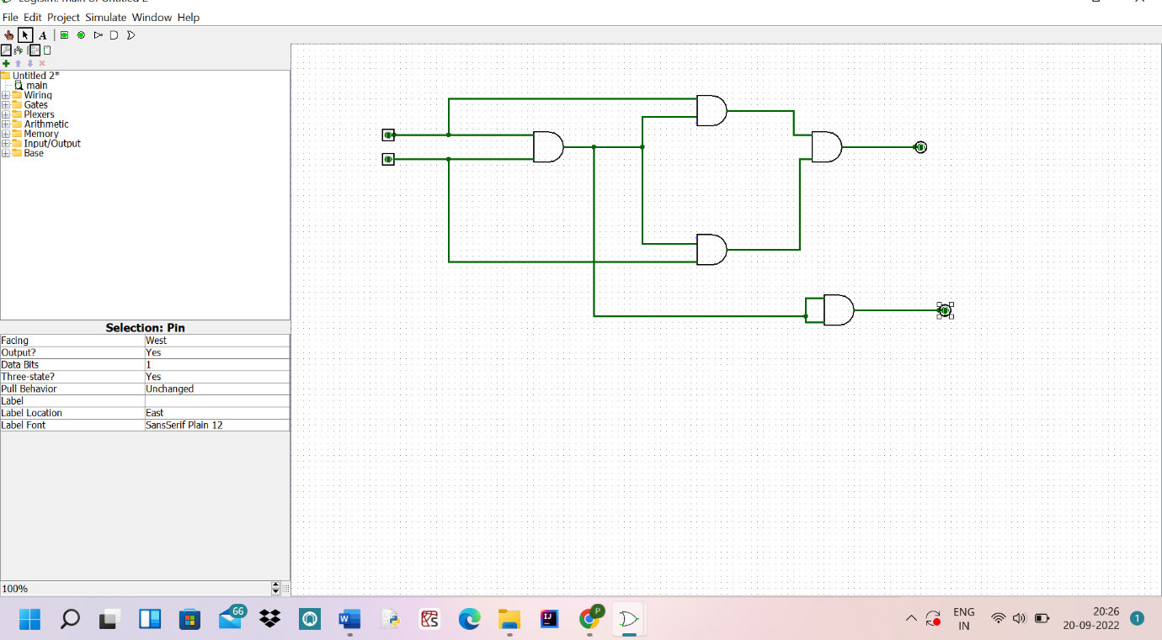

11. Design and implement 2-bit half adder with NAND using logisim simulator.

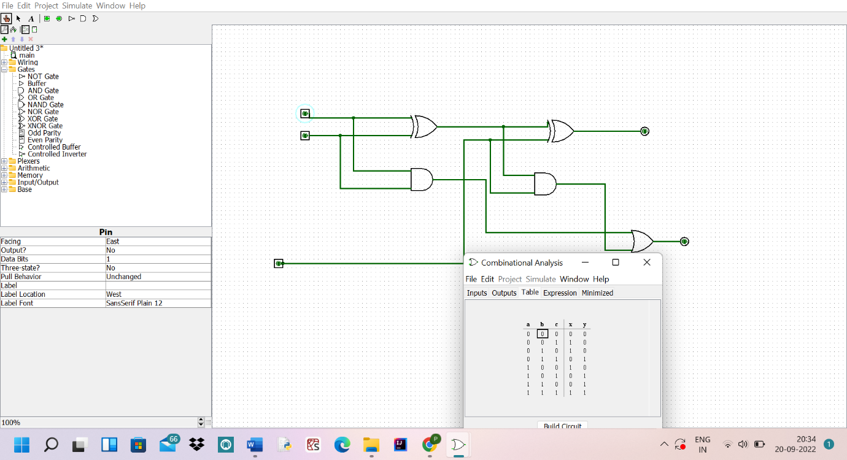

12. Write an assembly language program to find factorial of n in the given number.

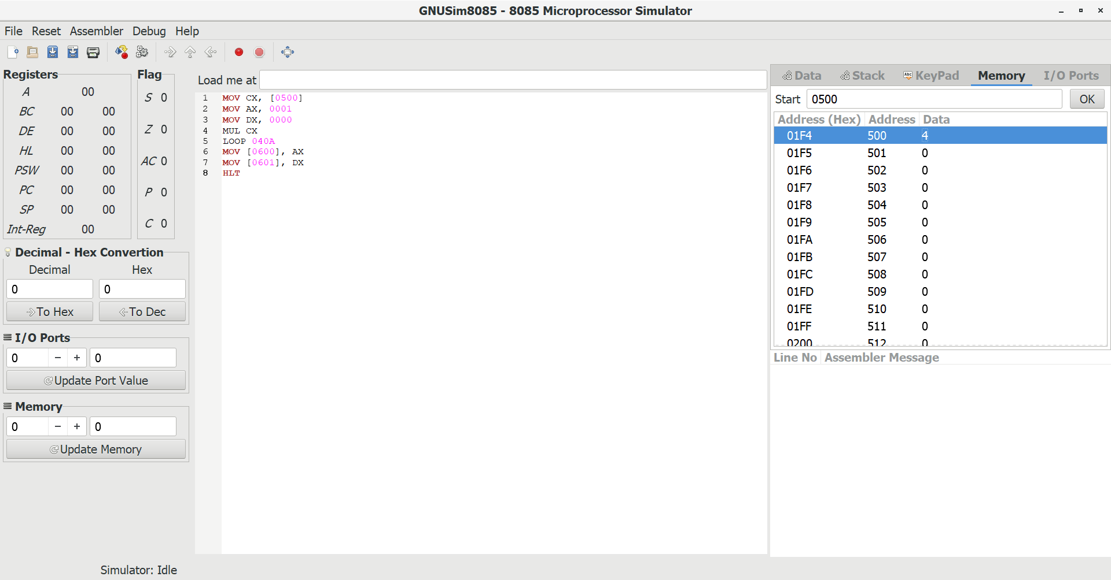

21. Write a program to convert Decimal number to Binary number using any high level language.

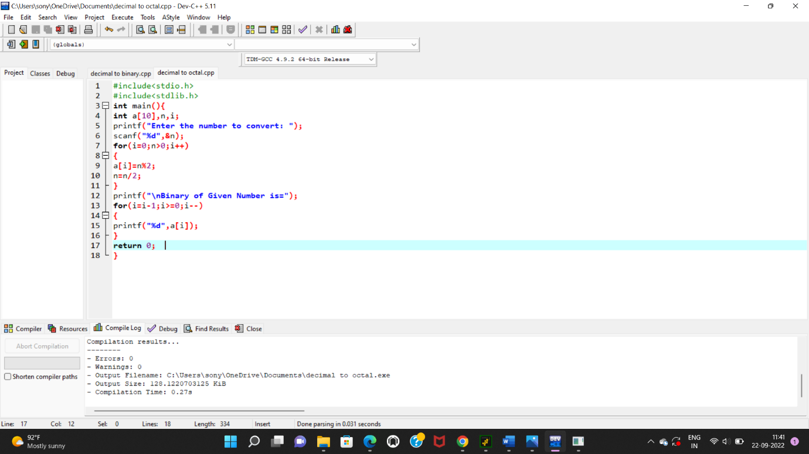

22. Write a program to convert Decimal number to an Octal number using any high level language.

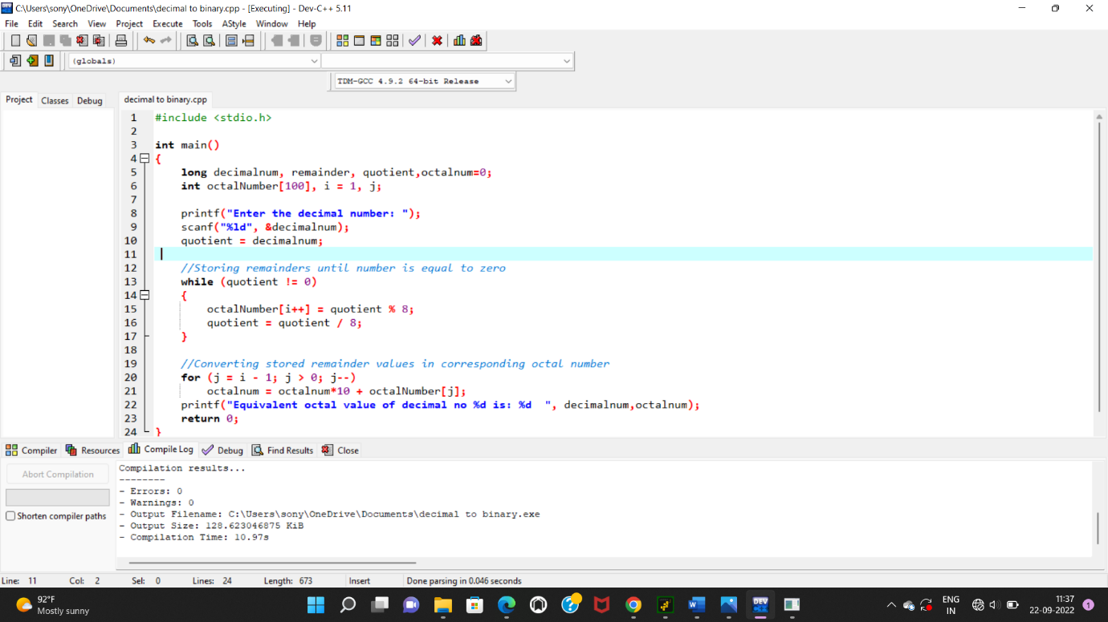

23. Write a program to convert Binary number to Decimal number using any high level language.

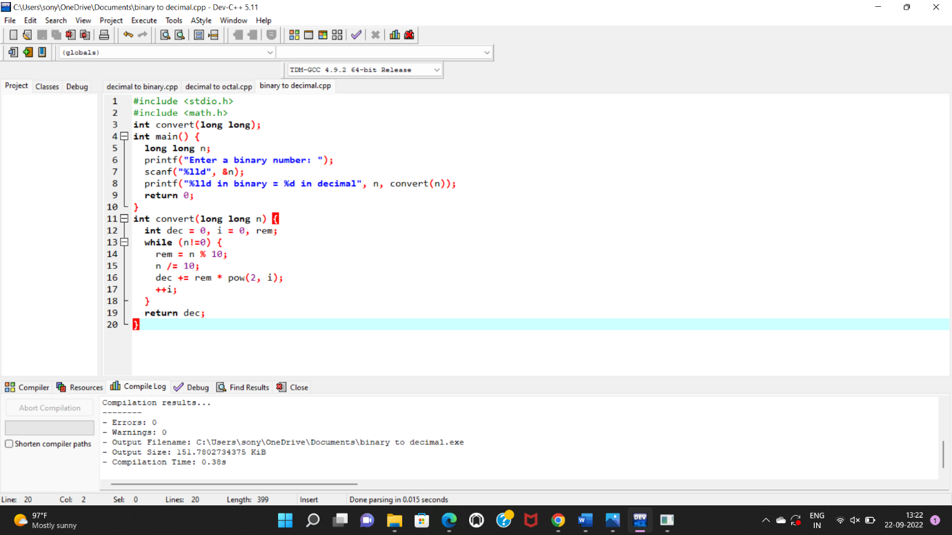

17. Write a program to perform Booth’s multiplication of two signed numbers using any high level language.

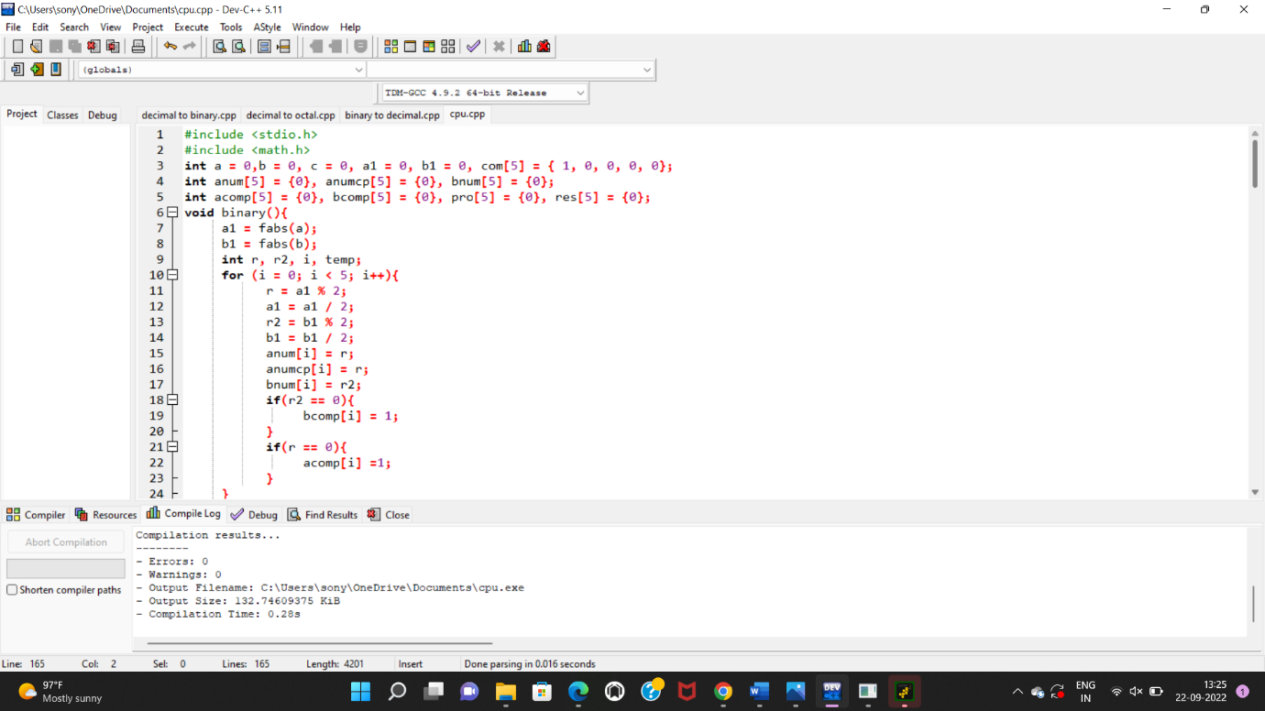

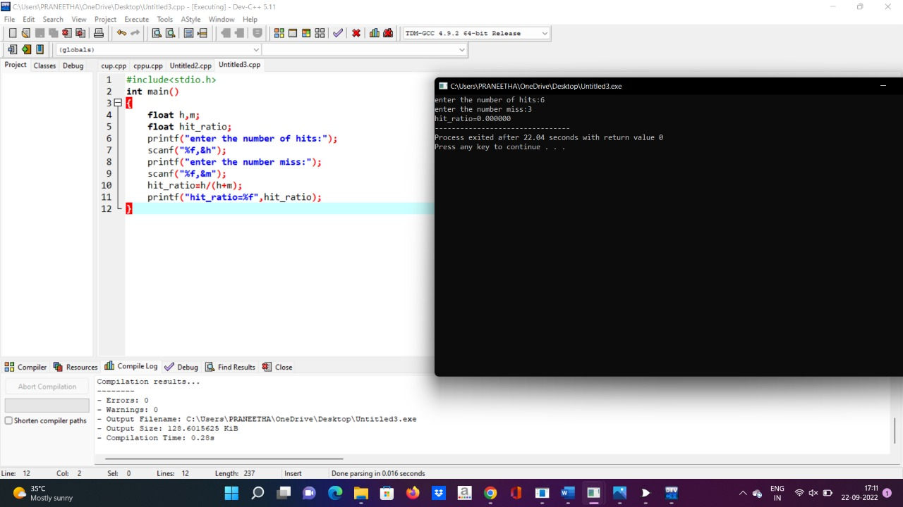

25.Write an assembly language program to swap two 8-bit datausing 8085 processor.

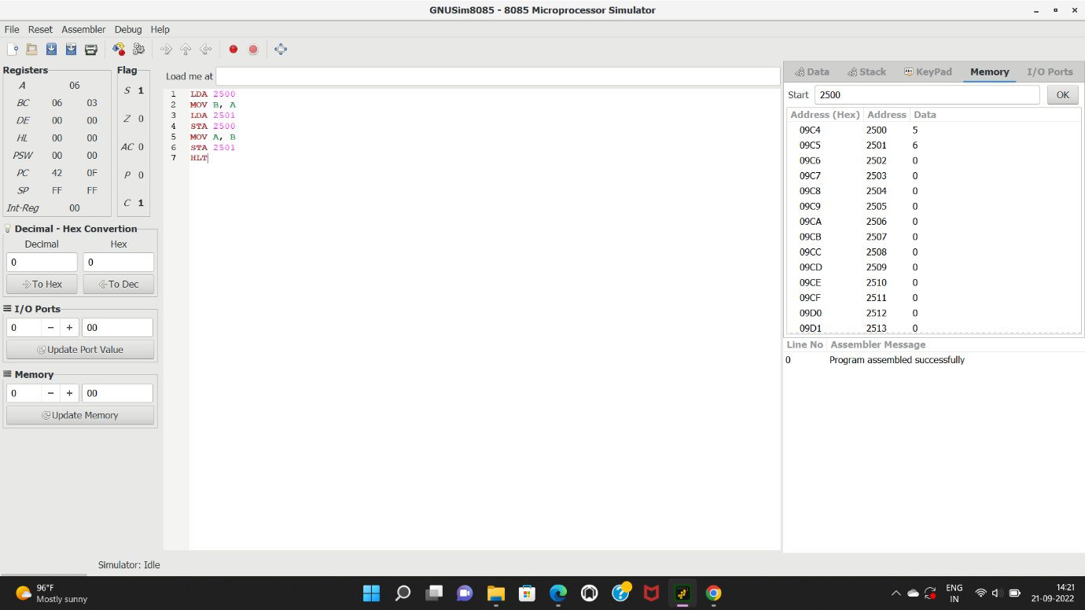

20. Write an assembly language program to find 1’s and 2’s complement of 8 bit number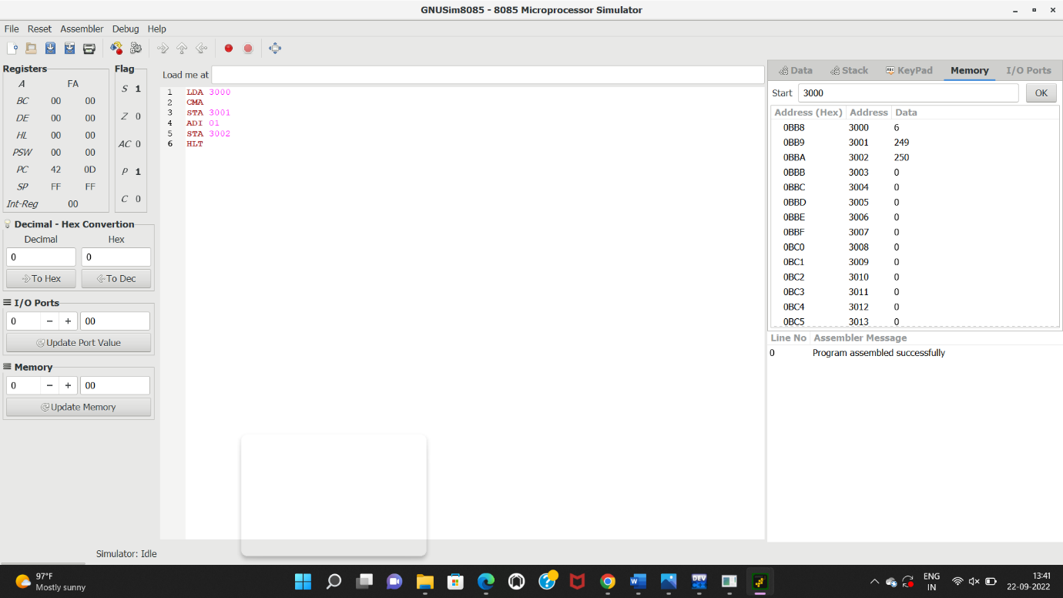

13.Write an assembly language program to find the largest number in an array.

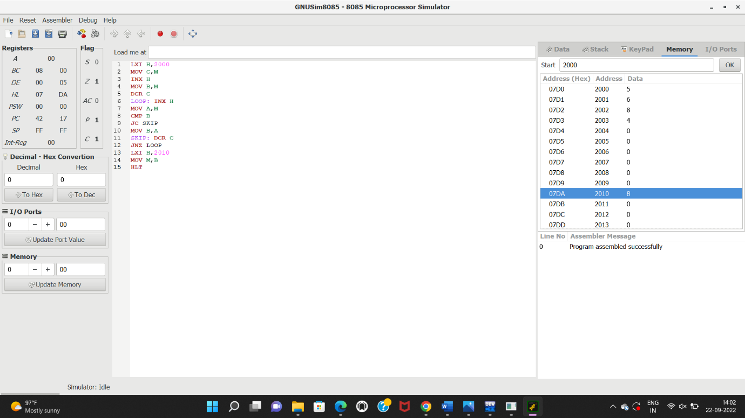

1. Write a program to perform Booth’s multiplication of two signed numbers using any high level language.



18. Write a program to perform Restoring Division of two numbers using any high level language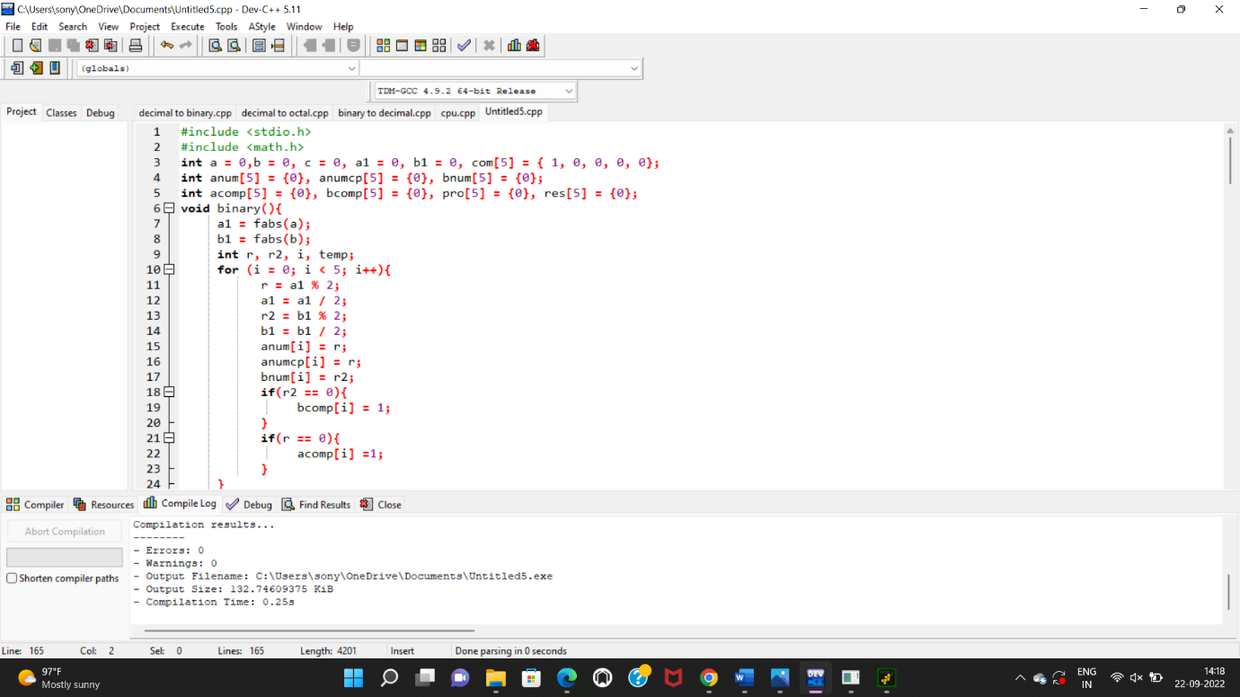

.

19. Write a program to find the Hit ratio for the given number of Hits and Misses in Cache memory using any high level language.

